“Already in Progress” Message when Trying to Run MPS/MRP

Sage 50

You may experience the following message when you attempt to run the MPS feature within the Planning module in Sage 50 Manufacturing.
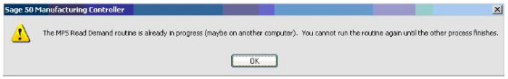
The most frequent cause of this problem is if MPS/MRP is being run and the Sage 50 Manufacturing software closes unexpectedly i.e. due to a power cut, computer failure or another issue within Sage 50 Manufacturing causing the software to close. This message is presented with the program is re-opened and you attempt to run MPS/MRP again. However, you may legitimately experience the message if someone is running the MPS/MRP routine on another computer. If this is the case, please be patient and wait for the routine to finish.
To resolve this issue you will need to ask all users to log out of Sage 50 Accounts and Sage 50 Manufacturing. A single user may need to log into Sage 50 Manufacturing as ‘Manager’ or another user with access to the Maintenance routine.
- Go to File > Maintenance from the top left corner of your Manufacturing software
- Select Check Data
- The ‘Choose Actions’ screen will appear. Deselect all currently ticked features and then put a tick in the box entitled ‘Reset MPS and MRP in Progress Flags’. The screen should now look like this:
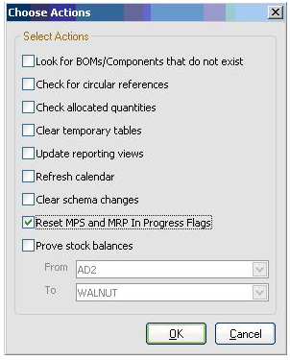
- Click OK
- Close the File Maintenance screen
- Re-run MPS/MRP – it will now work as normal

